Artwork Analyser
Artwork Analyser is a web app that instantly evaluates your artwork files for print quality readiness.
[UPLOAD SECTION]
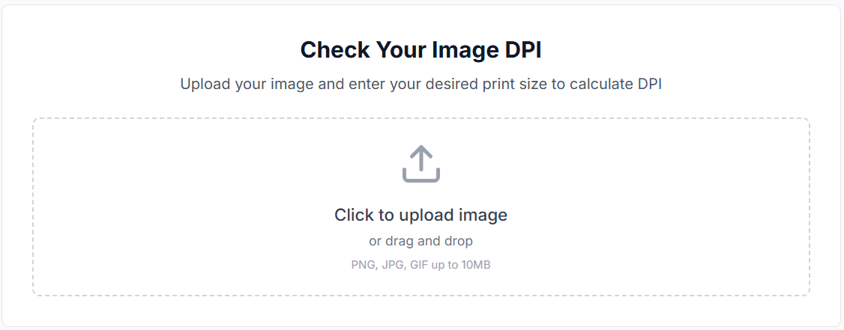
Upload a PNG or PDF, and within seconds you’ll receive a complete technical breakdown—plus guidance on how well your file will reproduce with DTF, UV DTF, and/or other printing methods.
Updates Required…
Check Your Image Quality
Upload your artwork/image file and to see you artwork quality
PNG and PDF (SVG, EPS, AI and PSD coming soon!)
Example when uploaded
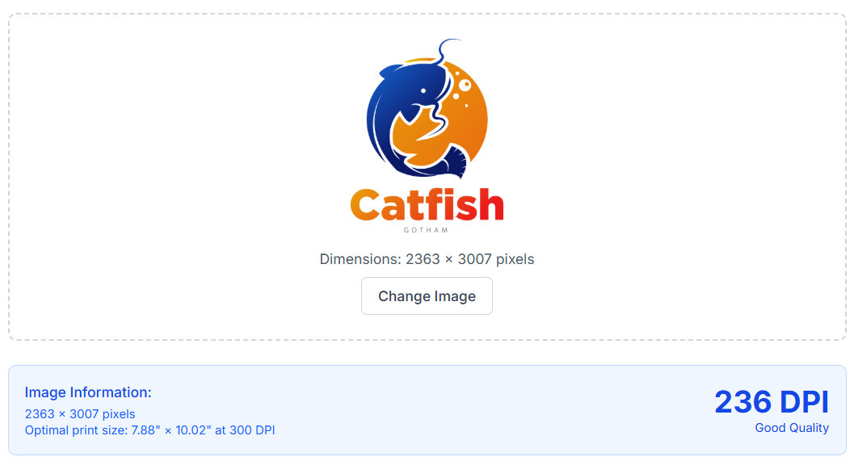
[REPORT SECTION]
{Report Information shows only here when available and after execution of adding the artwork file - it moves all the information below here… this is not copy for the page do not include it, its for your reference of what should show here}
[4 SECTION COLUMNS, SIDE BY SIDE DESIGN]
Core File Analysis
- Dimensions (pixels, aspect ratio, DPI, bit depth, alpha) fully extracted.
- File category and quality rating (“Optimal”) displayed.
- Recommended print sizes at **300 DPI** and **150 DPI** calculated correctly.
- ICC profile detection working (shows “Not embedded” when missing).
- Aspect ratio and category displayed clearly.
🧩 Comprehensive File Analysis
- Detects file type, pixel size, aspect ratio and alpha channel
- Calculates recommended print sizes at 300 DPI and 150 DPI
- Identifies embedded ICC profiles and bit depth
- Rates print quality as Optimal / Good / Poor
Updates Required…
ICC should be in the dimension and dpi area
The recommended print sizes area should include:
Optimal Resolution (greater than symbol) 300 DPI Artwork Sizes
Good Resolution (greater than symbol) 200 DPI Artwork Sizes
Poor Resolution (less than symbol) 150 DPI Artwork Sizes

🎨 Color Palette Extraction
- Extracts all reference RGB and HEX colors
- Highlights dominant colors by percentage
Updates Required…
The CSV and json need to have all the information in the sheet, by rgb and hex.

🤖 AI Artwork Assistant
- Chat directly about your artwork file
- Instant feedback on DPI, quality, colors, and print readiness
🛡️ Built-in DTF Safety Guidelines
- Checks minimum text ≥ 1.0 mm, hairlines ≥ 0.5 mm and/or 8-10 point
- Warns about transparency or semi-opacity issues
- Advises on flattening layers for better adhesion
- Automatically includes standard DTF prep reminders

How It Works
- Upload: drag-and-drop a PNG or PDF.
- Analyse: the app parses image data locally and builds a detailed Quality Report.
- Review: see DPI, dimensions, and color-palette instantly.
- Ask the AI: chat with the built-in Agent for print or color-management advice.
Key Benefits
Instant, accurate print-readiness feedback
Built-in AI expert for color & file questions
No upload delays — runs in-browser
Zero-cost, privacy-first design
Expandable to upscaling, halftoning, and advanced color correction

